**Governor Stirling Senior High School**

**2019 Year 12 Physics**

**Task 10: Test 5 – Relativity, Particle Physics and Cosmology**

RELATIVITY, PARTICLE PHYSICS AND COSMOLOGY

**NAME**: _________________________

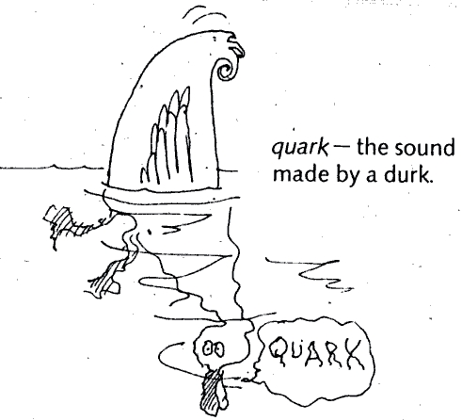:

**TEACHER**:______________________

**MARKS**:  **/55**

**Instructions:**

**Do not turn this paper over until you are told to do so**

* **Answer all questions.**
* **When calculating numerical answers, show your working or reasoning clearly. Give final answers to three significant figures and include appropriate units where applicable.**
* **When estimating numerical answers, show your working or reasoning clearly and give final answers to a maximum of two significant figures.**
* **Show working out steps neatly, logically and clearly to score full marks**
* **An approved scientific calculator may be used**
* **Write with a blue or black ink pen. You may use a lead pencil to draw diagrams.**

**Question 1 (10 marks)**

A linear accelerator is used to accelerate particles through a series of tubes (drift tubes). There is a potential difference between each pair of tubes that accelerates the ions.

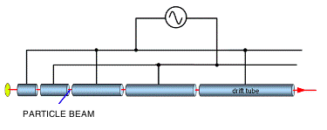

The ends of two consecutive tubes in a linear accelerator have a potential difference of   
10 000 V across them. A beam of electrons with a speed of 1.80 x 104 m s-1 travels across a   
3.00 cm gap between the two tubes.

1. Calculate the electric field strength between the tubes. (2 marks)

1. Calculate the work done on each electron by the electric field between the gaps. (2 marks)

1. Calculate the speed of the electrons when they enter the second tube. (4 marks)

1. Is the final speed of the electrons sufficiently high for the effects of the Theory of Special Relativity to significantly affect their motion? Explain. (2 marks)

_______________________________________________________________________

_______________________________________________________________________

_______________________________________________________________________

**Question 2 (4 marks)**

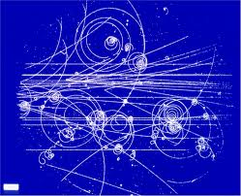High-energy particle physicists have discovered a new sub-atomic particle that is produced as a by-product of extremely energetic collisions between other particles in their particle accelerator. When produced, the new sub-atomic particle moves at 99% of the speed of light; it has a mass of 4.70 x 10-25 kg and decays with an average lifetime of 22 μs. Would these new sub-atomic particles have the same mass and average lifetime if they could be produced at rest in the laboratory? Briefly explain your answer. No calculations are required.

_________________________________________________________________________________

_________________________________________________________________________________

_________________________________________________________________________________

_________________________________________________________________________________

_________________________________________________________________________________

_________________________________________________________________________________

**Question 3 (7 marks)**

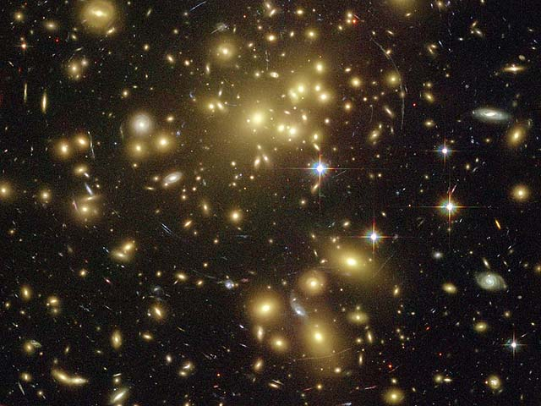Edwin Hubble established that distant galaxies are moving away from us with a velocity proportional to their distance; this relationship is written as v = H0 d where the constant of proportionality H0, known as Hubble’s constant, indicates the rate of expansion of the universe. A galaxy cluster that is 400 million light years distant is measured to be moving away from us at a speed of 8.7 x 106 m/s.

(a) Use this data about the galaxy cluster to estimate a value for Hubble’s constant in units of

*km/s* per *mega light*-*year.* (2 marks)

(b) Use your value of Hubble’s constant to estimate the age of the universe, expressing your answer to the nearest billion years. (3 marks)

(c) Distant galaxies moving away from us is evidence for the “Big Bang” theory. State the two other observations which also provide evidence for this. (2 marks)

_________________________________________________________________________________

Evidence 1: _______________________________________________________________________

_________________________________________________________________________________

Evidence 2: _______________________________________________________________________

_________________________________________________________________________________

**Question 4 (4 marks)**

The spectrum of light from most stars contains lines corresponding to helium gas.

Figure (*a*) shows the helium spectrum from the Sun.

Figure (*b*) shows the helium spectrum from a distant star.

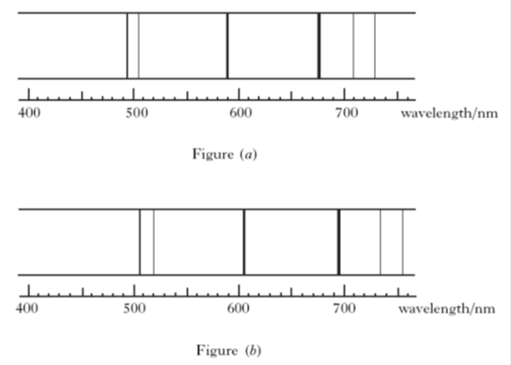

Given v = (Δλ/λo) c, where λO is the wavelength of a spectral line in the sun and Δλ is the change in wavelength of this spectral line in the distant star:

Estimate the recessional velocity of the galaxy from this spectral data.

**Question 5 (5 marks)**

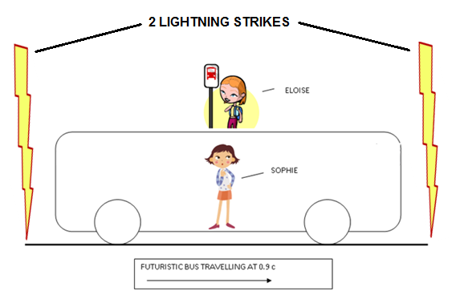Sophie is traveling on a futuristic bus that is travelling to the right at a constant speed of 90% of the speed of light. The bus travels straight past Eloise who was waiting for another bus. At the instant that the centre of the bus passes Eloise, she notices 2 lightning strikes at either end of the bus. Eloise observes that the 2 flashes of light occurred simultaneously (at the same time).

Eloise thinks that Sophie will see the lightning strike closest to the front of the bus first as the bus is “travelling to meet” the light from the front strike. In fact Sophie **does** observe the front strike first, but concludes that the front strike happened before the strike at the back of the bus.

1. Is one girl’s interpretation of the events more correct than the other’s? Explain carefully by making reference to Einstein’s Theory of Special Relativity. (2 marks)

_________________________________________________________________________________

_________________________________________________________________________________

_________________________________________________________________________________

_________________________________________________________________________________

_________________________________________________________________________________

1. How does Sophie explain that the two flashes of light reach Eloise simultaneously? (3 marks)

_________________________________________________________________________________

_________________________________________________________________________________

_________________________________________________________________________________

_________________________________________________________________________________

_________________________________________________________________________________

**Question 6 ( 7 marks)**

An alien observer on the planet Vulcan is witnessing a nearby battle between the United Federation of Planets and the Borg. The alien sees the Starship Enterprise chasing a Borg Cube.

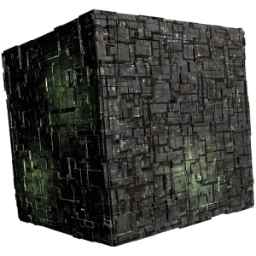

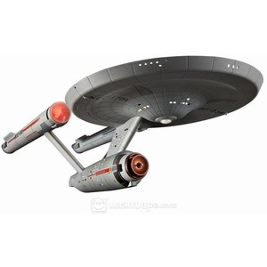

* + - * 1. He measures the Enterprise to be travelling at 0.90c and the Borg Cube to be travelling at 0.70c. Calculate the velocity of the Enterprise relative to the Borg cube.

(4 marks)

* + - * 1. The Borg ship fires a phasor beam (an extremely high frequency beam of light) at the Enterprise.

Determine how fast the crew of the Enterprise will see the beam travelling towards them

As predicted by Newton:

1. marks)

As predicted by Einstein:

(1 mark)

**Question 7 (8 marks)**

In the science fiction series *Willo Trek*, Captain Taylor decides to test his brand new starship with a quick trip from Earth to Pluto and back to Earth.



During the trip, the starship travelled at a speed of 0.98*c*

(*c* = speed of light). Captain Taylor’s identical twin brother, Doc Taylor, who remained on Earth, measured the total travel time to be 12.50 hours.

1. As seen by Doc Taylor on Earth, calculate the distance from Earth to Pluto in kilometres.

(2 marks)

1. As seen by Captain Taylor, calculate how far his journey would have been.

(2 marks)

1. What is the journey time as experienced by Captain Taylor?

(1 mark)

1. If it was possible for Doc Taylor to see the clock on the spaceship, how much time would he observe to pass on the spaceship during the trip?

(2 marks)

1. If it was possible for Captain Taylor to see Doc Taylor’s clock on the Earth, how much time would he observe to pass on the Earth during the trip?

(1 mark)

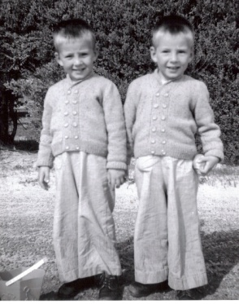

**Question 8 (10 marks)**

The standard model of particle physics proposes that heavy sub-atomic particles (hadrons), such as the proton or neutron, are actually composite particles made of different combinations of more fundamental particles known as quarks. There are 6 quarks whose properties are listed below.

|  |  |  |  |  |  |  |  |
| --- | --- | --- | --- | --- | --- | --- | --- |
| **NAME** | **SYMBOL** | **Charge (Q)** | **Baryon Number (B)** | **Strangeness (S)** | **Charm**  **(c)** | **Bottomness (b)** | **Topness**  **(t)** |
| *Up* | u | e |  | 0 | 0 | 0 | 0 |
| *Down* | d | e |  | 0 | 0 | 0 | 0 |
| *Strange* | s | e |  | -1 | 0 | 0 | 0 |
| *Charmed* | c | e |  | 0 | +1 | 0 | 0 |
| *Bottom* | b | e |  | 0 | 0 | -1 | 0 |
| *Top* | t | e |  | 0 | 0 | 0 | +1 |

(a) State the quark composition of the following hadrons: (3 marks)

(i) the Lamda-zero Ao , baryon with Q = 0, B = +1, and S = -1 and c = b = t = 0

(ii) the charmed Xi (Ξ+c) baryon, with Q = +1, B = +1, S = -1, c = +1 and b = t = 0

(iii) the D-zero meson, with Q = 0, B = 0, c = +1 and s = b = t = 0

(b) When a K– meson collides with a proton, the following reaction can take place.

$$K^{-}+p → K^{0}+K^{+}+X$$

X is a particle whose quark structure is to be determined.

The quark structure of the mesons in the reaction is given below.

|  |  |
| --- | --- |
| **particle** | **quark structure** |
| K– |  |
| K+ |  |
| K0 |  |

Is the original K– particle a hadron, a lepton or an exchange particle? Explain.

(2 marks)

____________________________________________________________________

____________________________________________________________________

Assuming this reaction occurs, determine the baryon number of X, and hence deduce the quark structure of X. Note: in this reaction the number and types of quarks are conserved.

(2 marks)

In order to answer Part (c) below, you will need to refer to the following table:

Table of Leptons:

|  |  |  |  |  |  |
| --- | --- | --- | --- | --- | --- |
| Lepton | Symbol | Charge | Le Number | Lμ number | Lτ number |
| Electron | e- | -1 | +1 | 0 | 0 |
| Electron neutrino | υe | 0 | +1 | 0 | 0 |
| Muon | μ- | -1 | 0 | +1 | 0 |
| Muon neutrino | υμ | 0 | 0 | +1 | 0 |
| Tau | τ- | -1 | 0 | 0 | +1 |
| tau neutrino | υτ | 0 | 0 | 0 | +1 |

* + - * 1. Consider the reaction as shown below.

μ- τ- + υμ + υτ

Determine whether the above reaction can take place. Justify your answer with appropriate workings, noting Baryon Number, Lepton Numbers and charge.

(3 marks)

**END OF TEST**